**Objective**

To identify trends in air, water, or soil pollution over time.

To detect seasonal variations or patterns in pollution levels.

To evaluate the impact of specific policies or events on pollution levels.

**Why Linear Regression?**

Linear regression is chosen for this analysis because

1. Trend Analysis: Identifies linear relationships between pollution and factors like time or emissions.

2. Prediction: Estimates future pollution levels based on historical data.

3. Simplicity: Easy to implement and interpret with clear coefficients.

4. Baseline Model: Provides a foundation before trying more complex models.

**CODING**

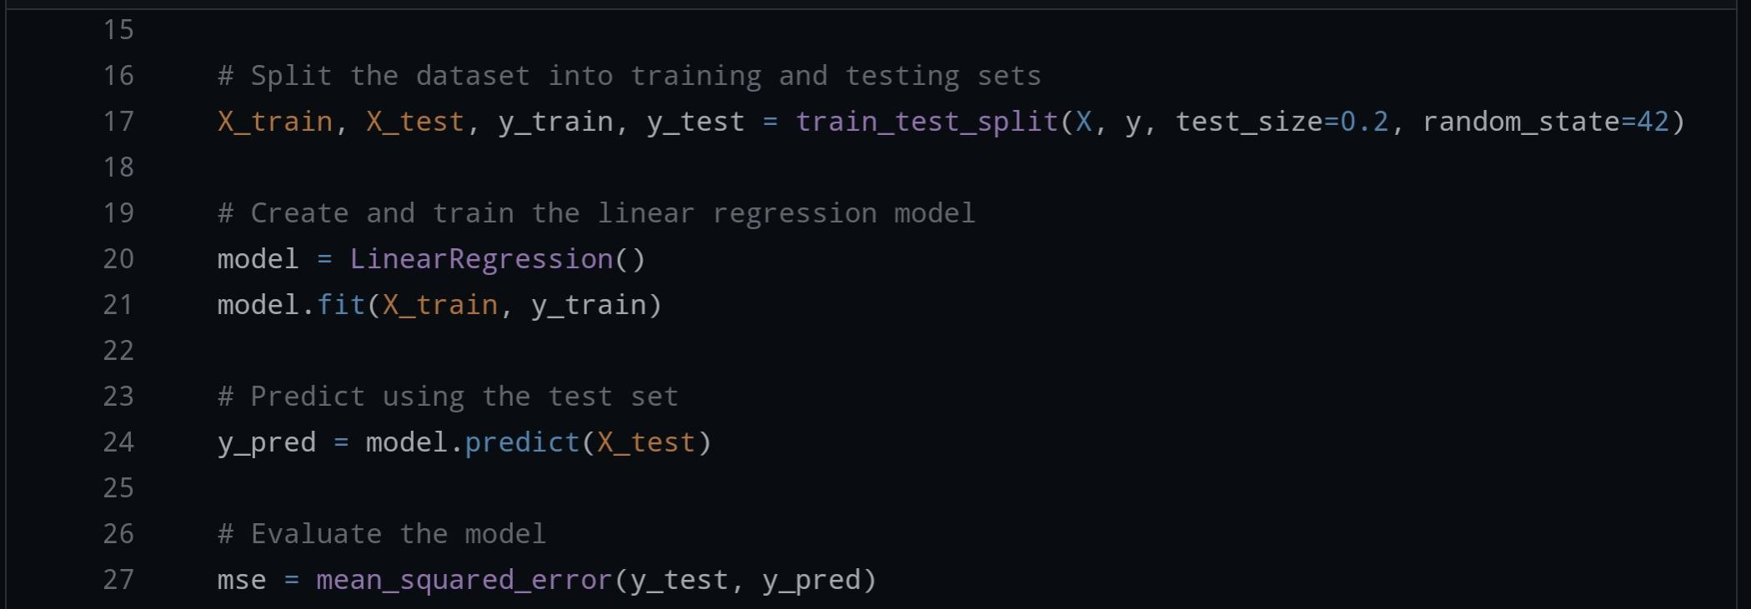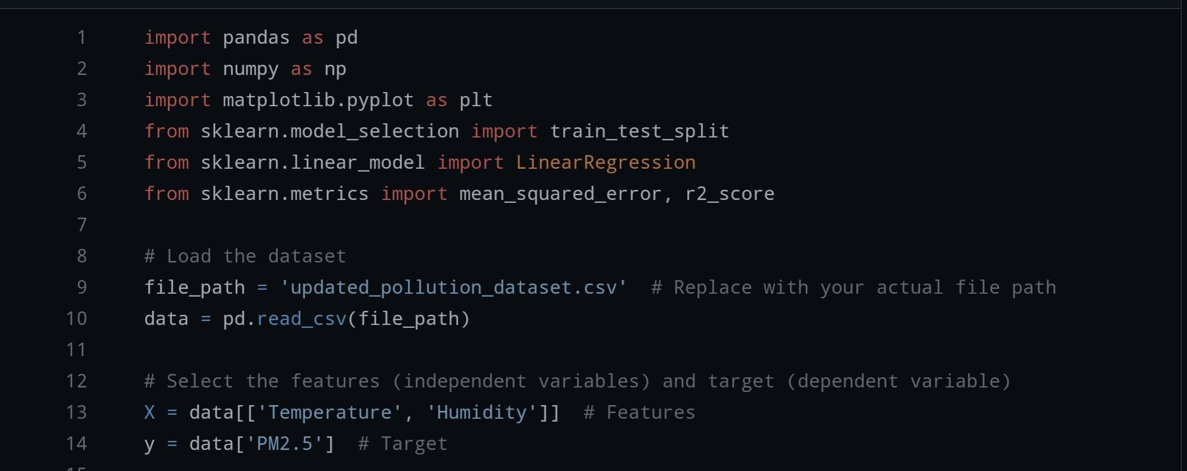

**Linear Regression Plot:**

